**DAA Lab Assignment 10**

**Shashank K**

**SE21UCSE198**

**CSE3**

**Introduction**

The question given is a connected weighed graph. Finding the minimum spanning will help us determine the minimum cost required to connect all the 11 cities(vertices). To do this we need to apply Kruskal’s algorithm to find the MST(Minimum Spanning Tree).

**Explanation**

In Kruskal’s method we first start with the edges with lowest weight and keep adding edges until the desired goal is reached.

**`set_disjoint` :** This method initializes the disjoint set data structure.

**`find`:** This method finds the root of the set to which the given vertex belongs to.

**`union`:** Joins two sets represented by `vertex1` and `vertex2`. It attaches tree with smaller rank to the root of the tree with larger rank.

**`kruskal`:** This is our driver method. Takes a graph input (dictionary). It first initializes the disjoint set, then sorts the edges by weights and iterates through the sorted edges adding them to the MST if there is no chance of circle formation.

**Complexities**

Time complexity : O(ELogE), Where E is number of number of edges. This complexity is due to sorting of the edges wrt given weights.

Space complexity: O(V), Where V is the number of vertices. We create a disjoint set data structure of size V.

**Output :**

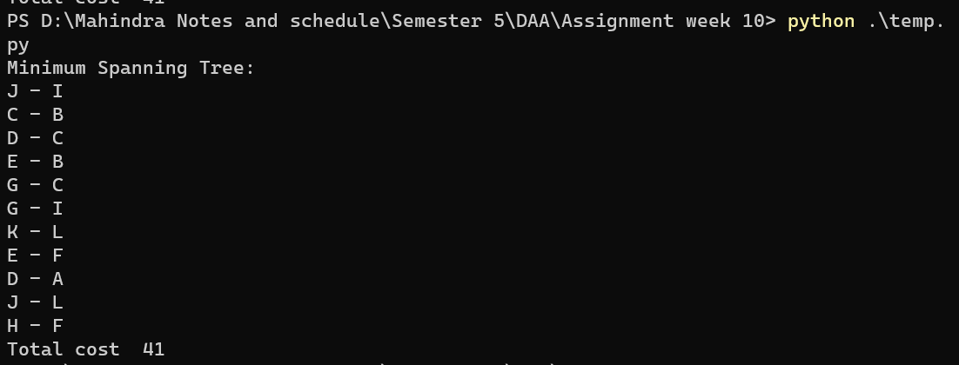

**Manual Calculation**